

**MAURITIUS TOURISM PROMOTION AUTHORITY**

**Award of Procurement**

**Notice Under Section 40 (7) of the Public Procurement Act**

**Selection of Consultant for Public Relations Services in Reunion Island**

**Refence: OAB/MTPA/2/2024**

This is to notify that, following a bidding exercise carried out by the Mauritius Tourism Promotion Authority (MTPA) for the **“Selection of Consultant for Public Relations Services in Reunion Island”** bearing the above reference, the contract has been awarded, as follows:

|  |  |  |  |
| --- | --- | --- | --- |
| **Consultant Name** | **Address** | **Contract Period** | **Contract Amount (Euros)** |
| Zoorit | 17, rue Monseigneur de Beaumont  97400 saint Denis  Ile de La Reunion | 1 year | **239,600** *(inclusive of taxes and any other charges)* |

**Director MTPA**

**28 May 2024**

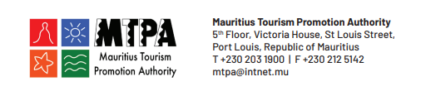

**www.mauritiusnow.com**