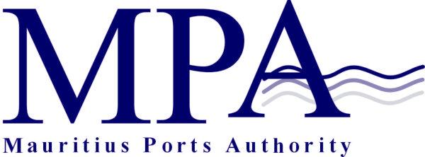
PROCUREMENT NOTICE
OPEN INTERNATIONAL BIDDING
(Authorised under Section 16 of the Public Procurement Act 2006)
CONSULTANCY SERVICES FOR THE EXTENSION OF THE CRUISE JETTY
CONTRACT MPA 678/2025

The Mauritius Ports Authority (MPA) is inviting proposals from suitably qualified Consultancy Firms for Consultancy Services for the Extension of the Cruise Jetty, as more fully described in the bidding document.

The bidding exercise will be conducted through Open International Bidding method according to the rules and regulations of the Republic of Mauritius.

Eligibility
The consultancy Firm shall have undertaken at least two (2) projects of similar nature and complexity over the last ten (10) years.

Bidders, specialized in the field, who are willing to participate in this exercise may contact the office of:

The Director, Legal, Risk & Administrative Services
Mauritius Ports Authority
H. Ramnarain Building
Mer Rouge, Port Louis
Tel: + 230 206 5400
Fax: +230 240 0856
Email: info@mauport.com

A complete set of bidding documents will be submitted to bidders via email.

Pre-Proposal Conference
A Pre-Proposal Conference will be held online on Monday 27 October 2025 at 13.30 hours (Mauritian Time). The link to get access online will be provided to bidders along with the Bidding Document as detailed above.

Submission of Proposals
Proposals (Technical & Financial in two separate sealed envelopes) shall be placed into an outer sealed envelope clearly marked “Contract MPA 678/2025 – Consultancy Services for the Extension of the Cruise Jetty and should be addressed to the Director General, Mauritius Ports Authority, 1st Floor, H. Ramnarain Building, Mer Rouge, Port Louis, Republic of Mauritius.

Deadline for the Submission of Proposals
Proposals should be either deposited in the Bid Box located in the Chief Officer’s Office, Mauritius Ports Authority, 1st floor, H. Ramnarain Building, Mer Rouge, Port Louis, Republic of Mauritius or submitted by registered post or courier so as to reach the Mauritius Ports Authority on or before Thursday 04 December 2025 up to 14.00 hours (Mauritian time) at latest.

Technical Proposals will be opened on the same day at 14.15 hrs. (Mauritian time) in the presence of bidders or their representatives who choose to attend.

Proposals received after the specified closing date and time will not be considered.

The Mauritius Ports Authority reserves the right to accept or reject any proposal and to annul the bidding process and reject all proposals at any time prior to award of the Contract, without thereby incurring any liability to any Bidder.

Mauritius Ports Authority
H. Ramnarain Building
Mer Rouge, Port Louis
Republic of Mauritius
Tel: +230 2065400
Fax: +230 2400856
Email: info@mauport.com

02 October 2025

