DEPARTMENT OF CIVIL AVIATION
SIR SEEWOOSAGUR RAMGOOLAM INTERNATIONAL AIRPORT
PLAINE MAGNIEN
REPUBLIC OF MAURITIUS
Tel: (230) 603 2000
Fax: (230) 637 3164
Email: civil-aviation@govmu.org

ADDENDUM No. 2
Dear All

Consultancy Services for the Supply, Installation, Testing and Commissioning of an Air Traffic Control Surveillance System and Associated Ancillaries for the Department of Civil Aviation

CAV/QUO: No.7 of 2025-26

With reference to the above-mentioned project, please find hereunder the replies to the following queries:

Query 1
Quote

We kindly request a six-week extension for the bid submission deadline.

Unquote

Answer 1
Prospective bidders are hereby informed that the closing date has been extended for Thursday 29 January 2026 at the same time.
Query 2
Quote

Could you please specify the desired ADS-B coverage range?

Unquote

Answer 2
The surveillance service will be used for approach control and therefore, the needed coverage is at least for the entire TMA (150 NM radius centered at PLS/VOR) of Mauritius. For enhancing safety in Mauritius airspace, surveillance approach control will also have to be provided for Rodrigues and Agalega. For a better coverage within our Flight Information Region (FIR), surveillance facility at St. Brandon has to be implemented.
…/2
Query 3
Quote
Would it be possible to provide a map indicating the areas where ADS-B coverage is required?
Unquote

Answer 3
The map indicating the required ADS-B coverage is given at Annex A.

Query 4
Quote
Does the required coverage extend to Rodrigues and the outer islands (Agalega and St. Brandon)?
Unquote

Answer 4
Please refer to the answer for Query 3. The ADS-B coverage for each island should be at least within a radius of 200 nautical miles.

Query 5
Quote

What is the maximum range of the surveillance coverage required? Should it meet the full extent of the Mauritius TMA or is it only required for the CTA/CTR of FIMP?
Unquote

Answer 5
Please refer to the answers for Queries 3 and 4.

Query 6
Quote

Will the surveillance system be used by ATC for separation assurance or only as an enhanced situational awareness tool? [This will impact the scope of technical requirements for system integrity.]

Unquote

Answer 6
The surveillance tool will be used for the separation of aircraft.
…/3
Query 7
Quote

Is ground movement surveillance required at FIMP? [This will generally require more sensors than a system assuring covering to the runway surface only.]

Unquote

Answer 7
Ground surface movement surveillance is not required.

Query 8
Quote

Is there a requirement for surveillance down to low-altitude at other airports such as Rodrigues? [This will require sensors located on or close to those airports.]

Unquote

Answer 8
This requirement may be considered as an option during the finalization of the client requirements.

Query 9
Quote

Is there any requirement or future plan to share surveillance data with La Reunion? [This may have an impact on site selection.]

Unquote

Answer 9
The sharing of surveillance data is not envisaged.

Query 10
Quote

We note that the stated scope of the RFP specifies only ADS-B surveillance. Is there any possibility that this may be later expanded to a multilateration requirement? [Multilateration systems will often use the same sensor equipment as ADS-B systems and may be considered as an incremental step in surveillance capability if this is considered early enough in the planning stage.]
Unquote
…/4
Answer 10
Multilateration may be considered as an option during the finalization of the client requirements

Query 11
Quote

Please confirm that the budget indicated in “Instructions to Consultants – Data Sheet”, Section 3.3(b), listed as Rs 20M, refers to 20 million Mauritian Rupees.

Unquote

Answer 11
Yes, Rs 20M refers to 20 Million Mauritian Rupees.

Query 12
Quote

As specified, we have initiated the process to register with the CIDB, although we are uncertain about the exact time frame for approval. We would also like clarification on the necessity of this requirement, as this project is a navaid project, as opposed to a construction project.
Could you please look into this and confirm whether CIDB registration is a mandatory requirement?

Unquote

Answer 12
CIDB registration is not mandatory for the consultant but the contractor or sub-contractors who will be executing the final contract (implementation of the surveillance system) will be required to register with CIDB in case civil works have to be carried out.

Yours faithfully

A BOOJHAWON (Mrs)
for Ag Director of Civil Aviation

Encl.

Annex A

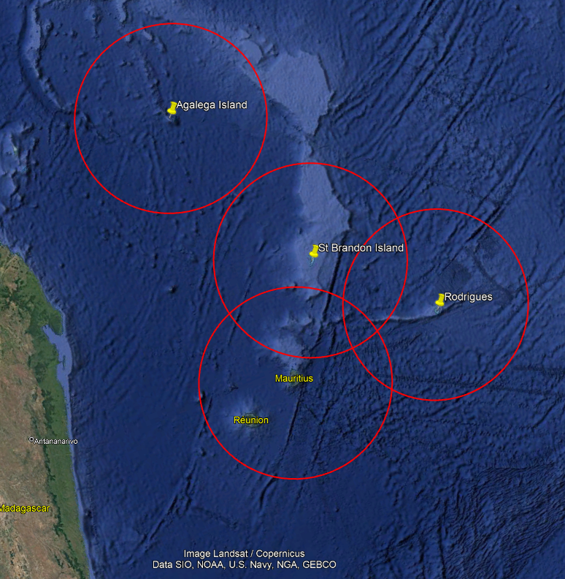

200 nautical miles around each island.

