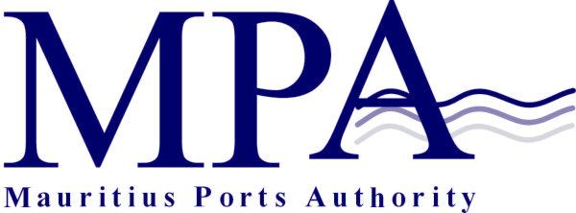
PROCUREMENT NOTICE
OPEN INTERNATIONAL BIDDING
(Authorised under Section 16 of the Public Procurement Act 2006)

CONSULTANCY SERVICES FOR YARD EXPANSION WORKS AT THE MCT
CONTRACT MPA 720/2026

The Mauritius Ports Authority (MPA) is inviting proposals from eligible and suitably qualified Consultancy Firms for Consultancy Services for Yard Expansion Works at the Mauritius Container Terminal (MCT), as morefully described in the bidding document.

Objective of the Project

The MPA intends to expand the container stacking area to accommodate the increasing container traffic and a new gate complex. The project, which is expected to be implemented in line with international best practices, also includes a new customs verification area to ensure seamless terminal operations.

The bidding exercise will be conducted through Open International Bidding method according to the procurement rules and regulations issued by the Procurement Policy Office of the Republic of Mauritius.

In accordance with Construction Industry Authority Act 2023, Consultants, whether local or foreign under an existing or intended joint venture operating in the construction sector have the statutory obligation to be registered with the Construction Industry Authority (CIA), as appropriate, prior to bidding for the project. Consultants are thus strongly advised to consult the website of the CIA (ciamauritius.org) for further details concerning registration of consultants.

The consultancy Firm shall have undertaken at least 3 projects of similar nature and complexity over the last 10 years.

Bidders, specialized in the field, who are willing to participate in this exercise may contact the office of:

The Director, Legal, Risk & Administrative Services
Mauritius Ports Authority
H. Ramnarain Building
Mer Rouge, Port Louis
Republic of Mauritius
Tel: + 230 206 5400
Fax: +230 240 0856
Email: info@mauport.com

A complete set of bidding documents will be submitted to bidders via email.

Pre-Proposal Conference
A Pre-Proposal Conference will be held online on Thursday 18 June 2026 at 13.30 hours (Mauritian Time). The link to get access online will be provided to bidders along with the Bidding Document as detailed above.

Submission of Proposals
Proposals (Technical & Financial in two separate sealed envelopes) shall be placed into an outer sealed envelope clearly marked “Contract MPA 720/2026 – Consultancy Services for Yard Expansion Works at the MCT, and should be addressed to the Director General, Mauritius Ports Authority, 1st Floor, H. Ramnarain Building, Mer Rouge, Port Louis, Republic of Mauritius.

Deadline for the Submission of Proposals
Proposals should be either deposited in the Bid Box located in the Chief Officer’s Office, Mauritius Ports Authority, 1st floor, H. Ramnarain Building, Mer Rouge, Port Louis, Republic of Mauritius or submitted by registered post or courier so as to reach the Mauritius Ports Authority on or before Thursday 30 July 2026 up to 14.00 hours (Mauritian time) at latest.

Technical Proposals will be opened on the same day at 14.15 hours (Mauritian time) in the presence of bidders or their representatives who choose to attend.

Proposals received after the specified closing date and time will not be considered.

The Mauritius Ports Authority reserves the right to accept or reject any proposal and to annul the bidding process and reject all proposals at any time prior to award of the Contract, without thereby incurring any liability to any Bidder.

Mauritius Ports Authority
H. Ramnarain Building
Mer Rouge, Port Louis
Republic of Mauritius
Tel: +230 2065400
Fax: +230 2400856
Email: info@mauport.com

01 June 2026

